

Tropical cyclones: Teacher note

A cyclone is a violent tropical storm characterised by high-velocity winds and torrential rain, swirling around an area of low pressure. The winds and rain associated with a cyclone can cause extensive damage. A notable cyclone in 2011 was Cyclone Yasi, which resulted in the towns of Mission Beach, Tully, Innisfail and Caldwell being extensively damaged. Homes, crops and beaches were completely destroyed by the winds. Towns also suffered severe flooding.
The definitions below will give an understanding of the difference between the following weather events.
Weather event | Details
cyclone | Cyclones form over warm tropical waters where the sea’s surface temperature is above approximately 26.5 °C. They are typically hundreds of kilometres in diameter and can last for many days, with sustained winds greater than 62 km/h, or for severe cyclones, greater than 118 km/h. Strong winds, heavy rain, flooding and storm surges can cause major damage. Tropical cyclones rotate in a clockwise direction in the southern hemisphere and anticlockwise in the northern hemisphere.
typhoon | A typhoon is a regionally specific name for a severe tropical cyclone in the north-west Pacific Ocean west of the dateline. Typhoons form in the northern hemisphere and rotate in an anticlockwise direction.
hurricane | A hurricane is a regionally specific name for a severe tropical cyclone in the North Atlantic Ocean, the north-east Pacific Ocean east of the dateline, or the South Pacific Ocean east of 160°E. Hurricanes form in the northern hemisphere and rotate in an anticlockwise direction.
tornado | Tornadoes are violently rotating columns of air over land, associated with a severe thunderstorm. They range in diameter from metres to hundreds of metres and in duration from seconds to half an hour. Tornadoes form over land. In the northern hemisphere, they rotate in an anticlockwise direction while in the southern hemisphere, they rotate in a clockwise direction.

Reference: Tropical Cyclones FAQ (Australian Government, Bureau of Meteorology 2013) http://www.bom.gov.au/cyclone (accessed 19/02/13)

Drawing an annotated diagram

An annotated diagram is a labelled diagram with the addition of annotations to explain processes or relationships. An annotated diagram must include:
- a title
- accurate line drawing of the object (using a pencil)
- labels (using print script) indicating the main features or parts of the object
- annotations explaining processes or relationships
- straight lines (drawn using a ruler) connecting labels and arrows indicating processes and relationships.

Students are asked to draw an annotated diagram to illustrate the characteristics of a tropical cyclone. It needs to include comments to describe the processes involved in the formation of the cyclone.

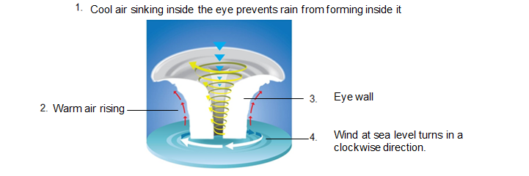

Investigation: Convection currents

Convection currents are vertical movements of hot and cold air or water. The movement of convection currents (warm air rising and cool air sinking) contributes to the formation of cyclones. The investigation is to help model the movement of warm and cool air in convection currents.

Helpful hints
- The ice cubes need to be prepared before the lesson. Add a lot of blue food colouring to the water before freezing for best results. Freeze an opened paper clip in each ice cube so that the ice cube can be hooked over the container and doesn’t float away.
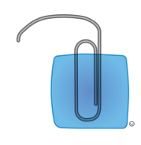
- Use a pipette or eye dropper so that the red food colouring is carefully placed close to the bottom of the transparent container as the movement of the red food colouring through the water shows the presence of the convection currents in the water.
- Ensure the investigation is conducted on a firm flat surface.

Note: Convection is learned in detail in Year 9.

Investigate how cyclones are formed using a model

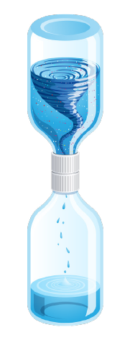
When tropical cyclones form, the wind spirals inwards in a clockwise direction and the movement creates a vortex around the eye of the cyclone. In the ‘cyclone in a bottle’ investigation students create a model to show this. It highlights the direction of spin (clockwise) and the development of a vortex (eye) in a cyclone.

There are limitations to this model. In this model, the air pressure in the bottom bottle needs to be released. When the water is swirled, the air travels upwards through the eye of the vortex. This is not what happens in the eye of a cyclone. As can be seen in the modelled diagram, warm air rises up outside of the cyclone and cool air sinks inside the eye of the cyclone. The science knowledge from the previous investigation about convection currents needs to be reinforced.
If you don’t have a tornado tube plastic connector there are instructions below for constructing an alternative.
Tornado tube connector alternative
Three-quarters fill one bottle with water. Add the glitter to the water. Place a metal washer, the size of the bottle opening, on top of the bottle. Align the top of the other bottle (empty) over the metal washer and then use duct tape to stick the two bottles together.
Alternatively, if you don’t have duct tape and a metal washer, you might like to try gluing the two bottle caps together (flat sides together) and drilling or tapping one hole through both caps.

